Girl’s Dress Code: Yes and No  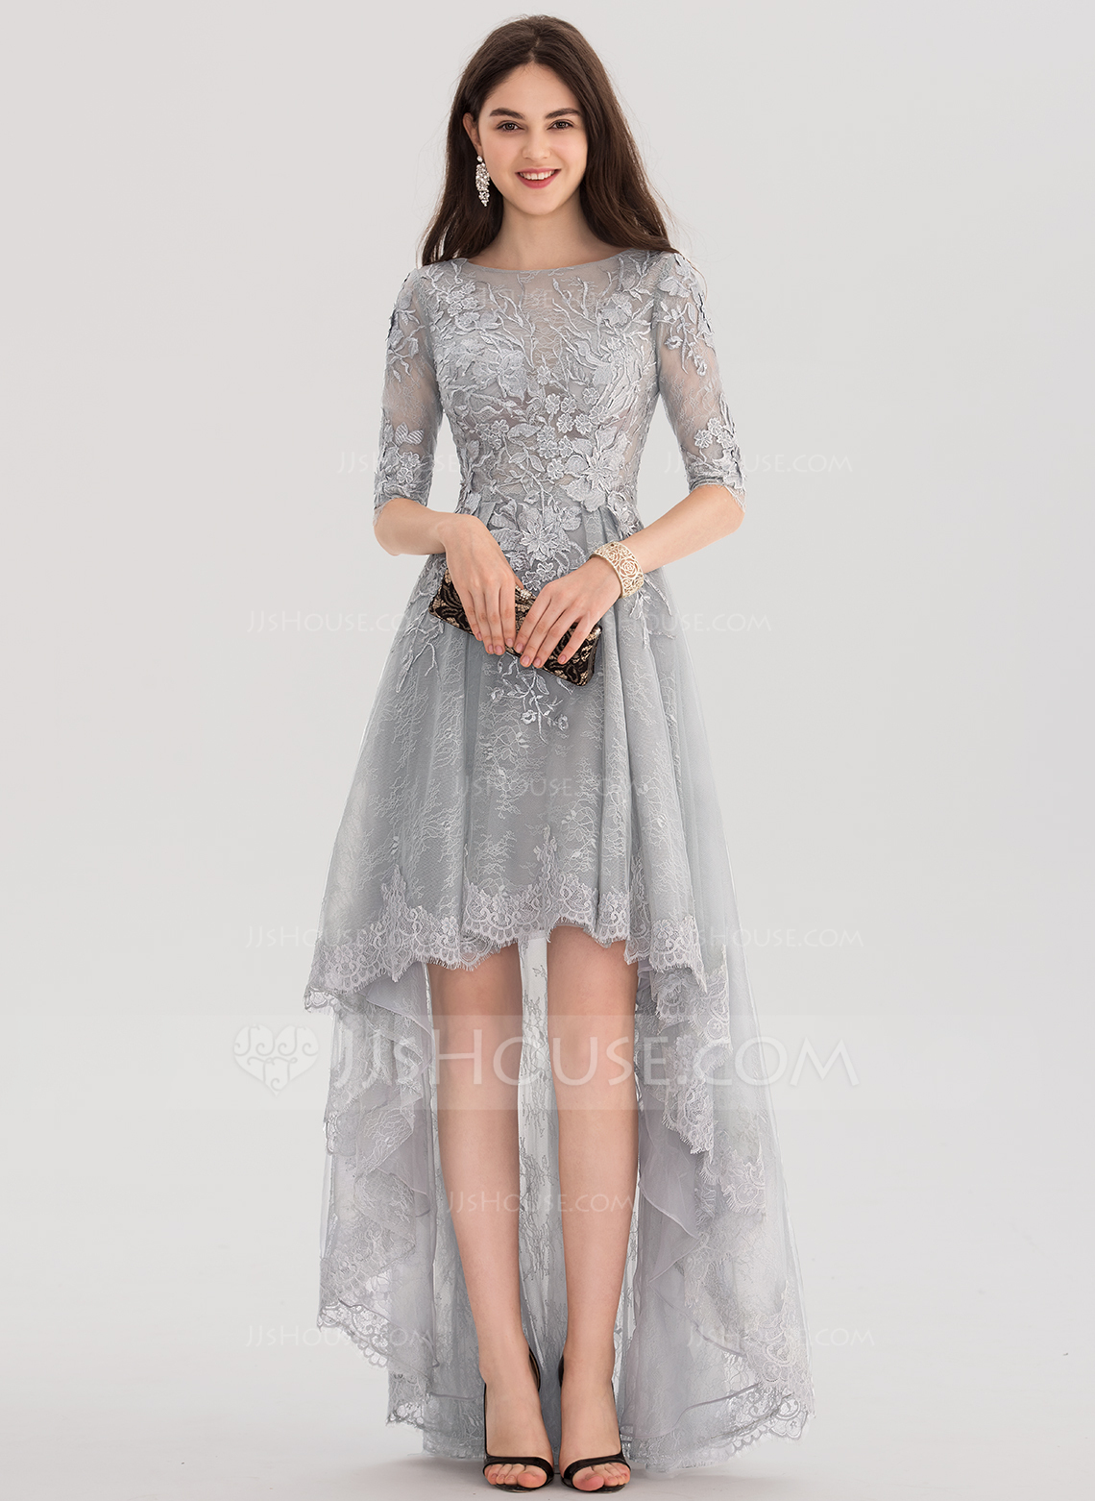  Do’s and Dont’s for Girls  Dates as well  Dresses should not be more than inch above the knee.  Dresses should not have side or front/back slits go pass the knee.  Dresses should not show sides of your chest (breast) and the cleavage must be respectable (if you have questions please contact Ms. Vining).  Dresses may fish back and horseback dresses may be worn as long as the lower back is covered.  Dresses may be strapless as long as the chest is covered and supported.  No sheer dresses are permitted.  Sheer fabric under main fabric is acceptable but the following must be covered: the breast, bottom and upper legs are not showing thru sheer fabric. | EECHS Prom Dress Code  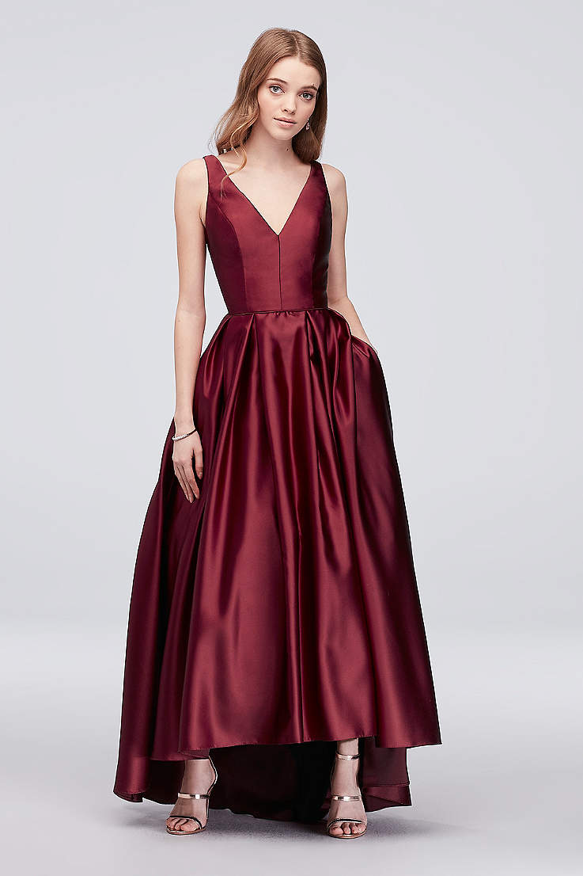  Girls Prom Dress  Dress Code  EECHS dress code for prom 2019 follows HISD Board Policy. We want to make sure students are aware this policy before purchasing a dress or tux. for the event.  If you have any questions, please contact Ms. Vining, Ms. Richards or Ms. Square @ 713-847-4809 or dvining@houstonisd.org or ssquare@houstonisd.org | Boy’s Dress Code: yes and No  Boys Tux  Do Nots for Boys  Dates as well  - No court shoes like high tops or tennis shoes.  - No shorts  - No jeans of any color  - No pants with tears or holes.  Do’s for Boys  - Tuxedo of any color  - Dress suits (with or with a tie)  - Dress shoes  - Socks

